Axe Preferences

Like all good apps Axe has some preferences.

Preferences

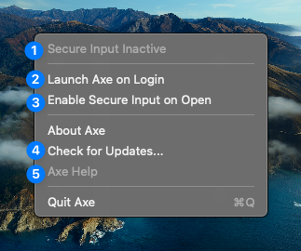

- Status of Axe.
- Enabling this will launch Axe, but not enable it, when you login.
- Enabling this will enable Axe as soon as it opens. Enable #2 and #3 if you want to automatically enable Axe as soon as you login to your computer.
- Checks for updates
- Opens the help book, you probably used that to get to here!

Linus Skucas
linus@linus.sh

